Shared Objects

Flash uses a class called “SharedObjects” to store and retrieve user information, similar to the idea of cookies.

This tutorial will show you how to store, retrieve, and utilize user name and last visited frame. The tutorial also contains directions for how to have the playhead go directly to the last visited frame upon subsequent start ups; skipping initial frames.
I have omitted basic steps such as adding keyframes and giving instances names to buttons.
Code appears both at the end of this file and in the .fla file.

- Create 3 layers called frameLabels, scripts, and Layer 1 respectively. In frameLabels, put 3 frame labels; one on frame 1 called frame1, one on frame 5 called frame5, and one on frame 10 called frame10.
- See following screen shot: on frame 1, add the following:
a) a text box named tbName --from the Window menu, choose Components, within Components, choose UserInterface, drag a TextInput onto the stage—it will be a movieclip, give it the instance name of tbName. This text box is where user will enter name.
b) a text box named tbName2 --from the Window menu, choose Components, within Components, choose UserInterface, drag a TextInput onto the stage—it will be a movieclip, give it the instance name of tbName2. This text box is where the user name will appear on start up.
c) a text box named tbFrameNumber --from the Window menu, choose Components, within Components, choose UserInterface, drag a TextInput onto the stage—it will be a movieclip, give it the instance name of tbFrameNumber. This is where the frame number will appear on start up.
d) add a button in the typical manner
e) in the screen shot, the labels in red are simply labels to help you understand how the stage relates to the code. The blue and green labels are to help the user interface along and would be modified by your screen design.
- In Frame 1, click on the stage to deselect all objects, click in the timeline on the scripts layer, open up the Actions window. Paste in Code that appears at end of this tutorial marked Code for Frame 1. Remember that the two backslashes (//) indicate comments and are ignored by the machine….just attempts by me to explain the code to you. Also remember that lines beginning with trace are just for checking output, not part of user experience.
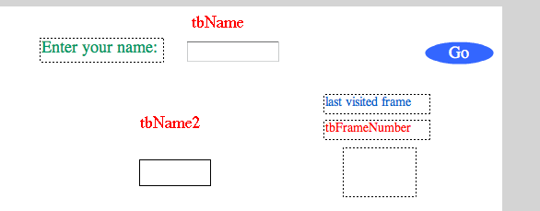

- See the following screen shot for Frame 5 in the timeline: add the following:
a) a text box named tbReceive --from the Window menu, choose Components, within Components, choose UserInterface, drag a TextInput onto the stage—it will be a movieclip, give it the instance name of tbReceive. This is where user name will appear.
b) from the Window menu, choose Components, within Components, choose UserInterface, drag a Label onto the stage—it will be a movieclip, give it the instance name of lblName
c) add a button in the typical manner
d) the labels in red are simply labels to help you understand how the stage relates to the code. The black labels “Hello” and “Nice to see you again” are to help the user interface along and would be modified by your screen design, except for the “Label” which is the default text of the label component.
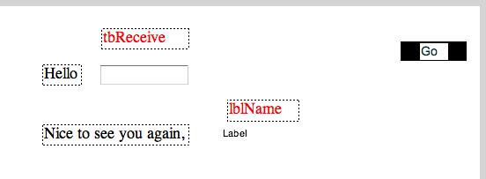
- In Frame 5, click on the stage to deselect all objects, open up the Actions window. Paste in Code that appears at end of this tutorial marked Code for Frame 5. Remember that the two backslashes (//) indicate comments are ignored by the machine….just attempts by me to explain the code to you.
- On Frame 10, insert a button that takes the playhead back to frame1. Insert a text box on Frame 10 that tells you that it is frame 10. In Frame 10, click on the stage to deselect all objects, open up the Actions window. Paste in Code that appears at end of this tutorial marked Code for Frame 10. Remember that the two backslashes (//) indicate comments are ignored by the machine….just attempts by me to explain the code to you.
- Control>Test Movie. On frame 1 enter a user name, click button and go to frame 5. Your user name should appear in both the text box and the label. Stop the test movie. Test Movie a second time. The user name should appear on frame 1. In addition frame 5 should also appear as that was the last visited frame (in the first running of test movie).
- In the timeline go to frame 1, click on the actionscript, scroll down. In the middle of the script there are comments and a block of code that refer to and include a case/switch statement. Follow the directions in the comments to uncomment the code (between the /* and the */). Control > Test Movie. This should take you to frame 5 right away.
In summary, you can store and use information within the application’s running and between separate running’s (on frame5, tbReceive, lblName, and on frame 1 tbName2). You can store a users location in your program (frameNumber) and use a case/switch statement to direct program accordingly. Case switch statements are just a way to modularize or bundle multiple if/then statements instead of having a serious of if/thens you use the case/switch.

Code appears on next pages.

Code for Frame 1

stop(); //stop playhead on this frame

var mysharedobject:SharedObject = SharedObject.getLocal("mycookie"); //create the Shared Object

tbName2.text = mysharedobject.data.firstname;
//tbName2 is the text box where user name will appear on start up

tbFrameNumber.text = mysharedobject.data.frameNumber;
//tbFrameNumber is the text box that shows the last visited
//frame, either 1, 5, or 10

var userName:String = ""; //create user name variable
var frameNumber:Number; // create frame number variable

mysharedobject.data.frameNumber = this.currentFrame;
//have the shared object understand it should get and keep the current //frame number
trace(mysharedobject.data.frameNumber); //see if it gets the frame number

//uncomment block below to have it go to last visited frame
//select it all, right click and remove comment
//upon new Test Movie it will go directly to last visited frame
//be careful that if frame 1 was last visited frame you will
//not get the visual feedback

//block of code begins next line

/*var frameToGoTo:String = tbFrameNumber.text;
trace(frameToGoTo);

switch (frameToGoTo) {
case "1":
gotoAndStop("frame1");
break;
case "5":
gotoAndStop("frame5");
break;
case "10":
gotoAndStop("frame10");
break;
}

*/
//the above switch/case statment sends it to last visited

//script for blue Go button named btn2
//standard button script

btn2.addEventListener(MouseEvent.CLICK, buttonClicked);
function buttonClicked(event:MouseEvent):void
{

var myVariable:String = tbName.text; //create variable to hold user name from tbName
userName = tbName.text; //assign variable with the user name from tbName

var mysharedobject:SharedObject = SharedObject.getLocal("mycookie");
mysharedobject.data.firstname = tbName.text;
//have shared object hold onto first name

var myUserName:String = ""; //set variable to empty
mysharedobject.data.myUserName = tbName.text; //set it to tbname
trace(mysharedobject.data.myUserName); //see if it gets it

tbFrameNumber.text = mysharedobject.data.frameNumber;

mysharedobject.flush(); //empty out the shared object info

tbName2.text = mysharedobject.data.firstname; //set tbName to sharedojbect variable

gotoAndStop("frame5");
}

//button script ends
Code for Frame 5

stop();

mysharedobject.data.frameNumber = this.currentFrame;
//set the sharedobject to the current frame number

tbReceive.text = userName; //set text of tbReceive to userName variable---from the sharedobject
lblName.text = userName; //set the text of lblName to userName
//just to show you can have the shared object put the info
//in either a textbox or a label

myButton2.addEventListener(MouseEvent.CLICK, buttonClicked2);
function buttonClicked2(event:MouseEvent):void
{

trace("leaving frame 5"); //see if we leave this frame
gotoAndStop("frame10");
}

Code for Frame 10

stop();
trace(this.currentFrame); //get the current frame to see if we are here
mysharedobject.data.frameNumber = this.currentFrame; //set the sharedobject to the current frame number

//script for button
btnSO.addEventListener(MouseEvent.CLICK, buttonClicked3);
function buttonClicked3(event:MouseEvent):void
{
gotoAndStop("frame1"); //for testing purposes
}

