Car Animation Tutorial:

- Open a new Flash Document. Save it as CarAnimation
- Name Layer 1 as Car
- With the Pencil tool or Brush tool draw/pain a car without wheels
- Select the car by double-click or use selection to draw imaginary box around it.
- While selected, Modify>Convert to Symbol. Make it a Movie Clip, name it Car.
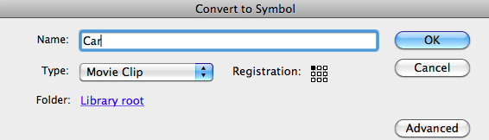
- Save the document
- Create a new Layer; name it Tire. Drag Tire Layer below Car Layer. Lock the Car layer.
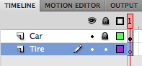
- Draw a tire and spokes on the Tire layer. Using selection tool draw imaginary selection box around the tire and spokes. Since car layer is locked you will not be able to select it.

- With tire and spokes selected go Modify>Convert to Symbol. Make it a Movie Clip named “Tire.” In the Window>Library you should see the car and tire movie symbols.
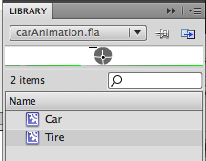
- Click Twice on the Symbol in the Library to enter Symbol Editing Mode. You will see the Main Timeline and the Movie Clip Symbol timeline next to each other. You will not see the car. [We will animate the tire symbol in and of itself. Remember the paddle wheel in Steamboat Willie was animating while other animations were going on simultaneously, that is the effect we are programming here].
- In the Symbol Editing Mode for the Tire symbol, insert a keyframe in frame 2 then select the Transform tool.
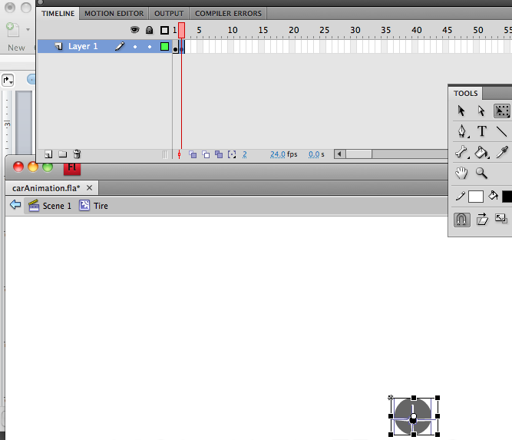
- Click on the top left selection of the box and turn the wheel to it shows that it has rotated roughly 45 degrees.
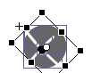
- Repeat the inserting of keyframes and rotating with transform tool for 5 frames and rotations.
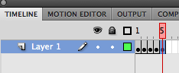
- Go Back to Scene 1 of the Main Timeline by Clicking on Scene 1 in the upper left of the timeline window.
- Delete the tire layer from the timeline. Right click or control click on layer, delete layer.
- On the Main Timeline drag a tire symbol and place at rear tire location. Repeat for front tire. You will need to unlock the car layer first.
- With Selection tool draw imaginary line around car and both tires to select them.
- While they are selected, go Modify>Group. Then Modify>Convert to Symbol. Make it a Movie Clip and name in RunningCar. Go To Control>Test Movie to see the animation. In Test Movie the output loops continuously so don’t be alarmed by the speed, its looping through 5 frames at 30 frames per second rate.
To review: We have 3 movie clips in the library (car, tire, and RunningCar).

