Background Animation
- Open a new Flash document and name it Background. Make sure the Library (window>library) is open so you can see the symbols as we create and use them.
- We will draw 1 building, convert it to symbol and repeat for 5 total houses.
- Remember if you draw separate elements (windows, doors) that you should Group, Modify>Group so that the symbol consists of all its elements. Group before you Modify>Convert to Symbol. Make each house its own Movie Clip. Do all the drawing in Frame 1, Layer 1, of Scene 1. Draw enough houses (6 or 7) so that they collectively extend off the stage. In the photo below the one on the right is off the stage. There are other ways to rapidly create houses. You can copy paste, change color, change tint (in properties), you can flip horizontally…
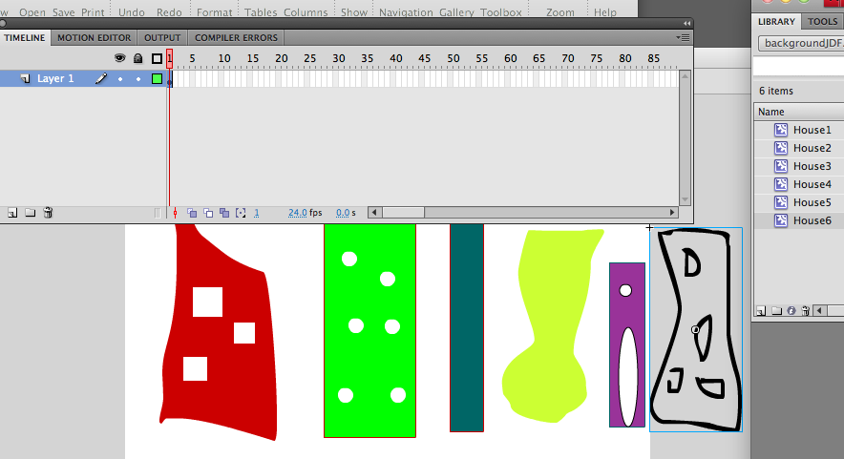
- Select all the houses with selection tool, Modify>Group, then Modify>Convert to Symbol. Make it a Movie Clip named skyline.
- In the library double click Skyline so we enter its Timeline. We will be staying in the Skyline Timeline now. Make certain you are in Skyline Timeline, frame 1, layer 1. Rename the layer sky1. Make sure the skyline is positioned on the stage with the leading edge at the left margin of the stage. See next photo.
- Insert a keyframe at frame 90.
- At frame 90 click in center of skyline symbol, drag the skyline to the left until it is about to exit the screen. Then Insert>Motion Tween anywhere between frame 2-89. If Flash wants to create a symbol do. You will be creating a tween when you see a dotted line following the path of your animation.
- Click on timeline sky1 layer. Edit>Copy.
- Lock sky1 Layer.
- Create a new layer called sky2. Click on frame 1 of sky2, move/drag the playhead and stop it where the last house is about to go ON screen.
- Click on sky1 layer, under the Eye symbol to make it invisible.
- To review, we have prevented any changes to sky1 layer, we cannot see it. Playhead is positioned where last house is about to come on screen, in that frame click on sky2 layer. See photo.
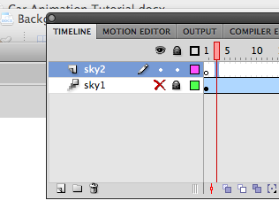
- Edit men>Paste in Center.
- Drag the houses to right off stage.
- Click on sky1 under Eye to turn in it visible. Position sky2 houses to be following sky1 houses. See photo. We are making a string of houses.
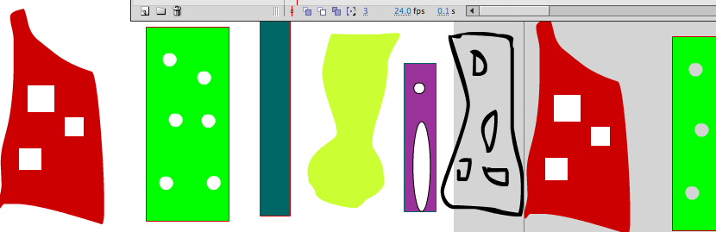
- On sky2 insert a keyframe at frame 90. On sky2 drag the houses to rest next to the first graphic. Insert a motion tween.
- Click on Scene 1, Control>Test Movie.

